**Introduction and Number System**

**Three Systems**

**By Odiscious Dozier**

**Trident University**

**Abstract**

AFKJKADFKAJ

Section 1.3 Major Components of a Digital Computer

INTRODCUTION

In today’s world market, laptops, tablets, and cellphones, are often considered too large and bulky or too slow and inconvenient and engineers work diligently to make user friendly enhancements. The demand, for such improvements, however, is not new. Ever since the ENIAC (Electronic Numerical Integrator and Calculator), which was the first general purpose computer, global societies have been striving to, empower, enrich, improve, and optimize, the Information Technology Industry.

To help understand some of the challenges faced, today, we must know what a computer system is. This discussion includes an illustration of a computer system’s basic block diagram. Definitions and explorations of, multiprogramming, multitasking, and a multiuser system, are given to help further illustrate the abilities and interworking of a computer system.

BODY

The major components of a digital computer are the, Central Processing Unit (CPU), Memory, and Input & Output (I/O) or Peripheral Devices – see Figure 1.

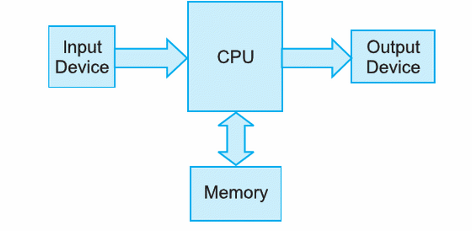

Input Devices vary, but the most common is the keyboard. These devices transfer user inputs into suitable 1s and 0s for a computer.

Output Devices vary, but the most common is the console or screen. These devices transfer 1s and 0s into suitable images or text for a user to digest.

The CPU is the brain of the machine, its primary function is to execute programs; however, it is also responsible for controlling the operations of all the other components of the machine – internal and external.

The Memory is comprised of three parts, main memory or RAM, secondary memory or auxiliary memory, and cache memory. RAM is volatile memory which does not persist when power is no longer provided to the machine. Auxiliary memory is non-volatile and responsible for storing, the Operating System (OS), data files, compilers, assemblers, application programs, etc.

Cache memory is much faster than RAM and it’s located between the CPU and the RAM. It stores data and instructions that are to be executed immediately. Websites often store data in Cached memory and can cause problems with web page rendering.

MULTIPROGRAMMING

In a multiprogramming system, there are one or more programs loaded in the main memory or RAM and are ready to execute. Due to only one program being able to have its instructions executed by the CPU, at a time, multiprogramming provides a way to keep the CPU busy and not idle as long as there are processes to execute.

For example, if there are programs being executed within the peripheral devices they may or may not be using the CPU. If they are independently executed from the CPU then, the CPU is considered to be in an idle state; thus, there is an opportunity to run or execute additional programs in the CPU. This allows for many programs to run simultaneously on a given computer system.

In order for a multiprogramming system to function appropriately, the Operating System (OS) must be able to allocate RAM for each separate process and ensure that processes do not interfere with each other. A couple of other problems that need to be addressed as well are, fragmentation and large programs may not fit in RAM. In the worst case if there are N programs to execute, if each program is heavily dependent on the CPU then the Nth program would have to wait for the other N-1 programs to execute.

MULTITASKING

MULTIUSER

CONCLUSION

REFERENCES

Multiprogramming, Multiprocessing, Multitasking, and Multithreading. (2013, October 24). Retrieved July 25, 2015.

Rom, B. (2007). Chapter 1: Introduction. Computer Fundamentals, Architecture and Organization. New Age International, New Delhi (Ebrary)

Rom, B. (2007). Chapter 2: Introduction. Computer Fundamentals, Architecture and Organization. New Age International, New Delhi (Ebrary)